# Week2 – Quiz

## Question 1

**We are interested in the Average Life Expectancy (ALE) for countries in different regions of the world. Below is a graph that shows the ALE in years for each country and Region in 2012 using the Gapminder dataset.**

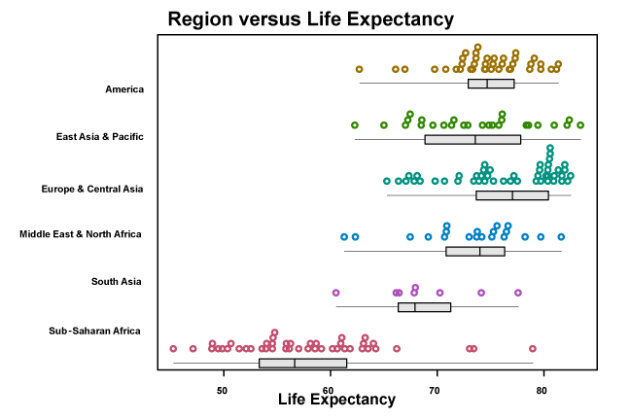

One of the statements is false. Select the **FALSE** statement.

Europe & Central Asia has the *biggest median*.

Every Region had *at least one country* with an *ALE value* over 75 years.

There is a *lot of overlap* in the data for all Regions except Sub Saharan Africa.

**The spread (*as summarised by the IQR*) for Sub-Saharan Africa is *much bigger* than for East Asia & Pacific.**

**Correct:**

This statement is **FALSE**. Sub-Saharan Africa’s IQR (box width) is similar if not smaller than that for East Asia & Pacific.

## Question 2

**The following statements refer to this plot of Average Life Expectancy (ALE) of people by Region over time: 1952 - 2008 from the Gapminder dataset.**

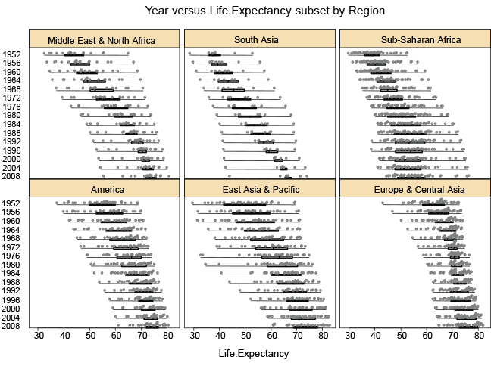

One of the statements is false. Select the **FALSE** statement.

For each Region, the median ALE has been larger in recent years than it was in 1952.

**The variability in ALE has reduced over time for all regions.**

For most Regions, the increases in median ALE have been slowing down over recent years.

**Correct**

This statement is **FALSE**. For example, the spread of the data for Sub-Saharan Africa has increased since the 1950s.